**BUILDING RELATIONSHIP**

 **ASSIGNMENT**

**DONE BY: -**

**AKSHAY K**

**TTC0822011**

|  |
| --- |
| **LIST OF CONTENT:** |
| **Introduction** |
| Case Study: |
| 1. Identifying Stakeholders |
| 2.Influence/Importance Matrix |
| 3. Project Overview |
| 4. RACI Matrix |
| 5. Negotiation Action Plan |
| 6. Stakeholders Engagement Strategy |
| **Conflicts and resolutions** |



# Building Relationships Introduction

Relationship building is **the ability to establish strong personal and professional bonds**. Communication, trust, support and equality are some important features of relationship-building abilities. Learning how to build relationships can help you discover new skills and achieve career success .

## What Is Relationship-Building Skills?

Relationship-building skills allow you to connect with others. They also help hiring managers assess your ability to form positive relationships. With these skills, you may find you are more able to get along with colleagues, work effectively as part of a team and build strong connections. Relationship-building skills can help you listen to others and make decisions that benefit all parties.

**Case Study:**

To achieve this unit you are required to read this case study and complete all 7 Building Relationships tasks within this assessment pack.

**Structure**

The Board of Ashleigh Pork is made up of:

The MD - the son-in-law of the original founder of the company who took over from Bob Ashville 12 months ago

The Finance Director who has been with the company for 35 years

The HR Director, recently appointed by the new MD

The Operations Director who has been with the company for 20 years

The Commercial Director who has been with Ashville Pork for 10 years and is responsible for Ashville’s successful relationship with the national supermarket chain Each of the 12 sites has a Site Manager who reports into the Operations Director.

At site level, Site Managers in the North always complain that sites in the South get preferential treatment when it comes to new initiatives and training, however all Managers are concerned about the resource and staffing implications of the project.

You have been engaged by the MD to work with the organisation to implement the required CI culture through a structured programme of training and consultancy support. You will identify and develop CI Champions throughout the organisation who will lead on and implement real factory-based projects. You will coach and encourage staff at all levels of the organisation to contribute ideas and to get involved, which will ultimately lead to the culture change to which the MD aspires.

**Building Relationships:**

**Task 1: -**

**Identify stakeholders:**

Please ensure that you have read the Case study: **Ashville Pork** before you begin to complete Task 1

Once you have read the case study you must complete the **Stakeholder Identification table** template below:

You will need to identify all the stakeholders from the case study and add them to the table, you must ensure that you identify each stakeholder’s interest in the project, what their influences are within the project and their importance to the project.

**Ashville Pork - Stakeholder Identification Table**

|  |  |  |  |
| --- | --- | --- | --- |
| **Stakeholder** | **Interest** | **Influence** | **Importance** |
| Bob Ashville (Founder) | Low | High | Meet their needs, keep satisfied |
| Financial Director | High | High | Key player, Engaged closely |
| MD | High | High | Key player, Engaged closely |
| HR Director | High | High | Key player, Engaged closely |
| Operational Director | High | Low | Show consideration, Keep informed |
| Commercial Director | High | High | Key player, Engaged closely |
| Site Manager | Low | High | Meet their needs, Keep satisfied |
| Employees | High | Low | Show consideration, Keep informed |
| Customers | Low | High | Meet their need, Keep satisfied |
| Marketing People | Low | Low | Least important, Minimal Effort |

**Building Relationships:**

**Task 2**: -

**Influence/Importance Matrix**

Please ensure that you have completed Task 1 the **Stakeholder Identification table**before you move on to task 2.

You must now complete the **Influence / Importance Matrix** provided below:

You will need to use the information you have collated within the stakeholder identification table and assess and identify each stakeholder influence and importance in relation to the below criteria, (A to D) i.e., who is the most important stakeholder and who has the most influences etc.  once you have done this you need to plot them on the**Influence / Importance Matrix**below.

A)    High importance low influences the “Victims

B)    High importance high influences the “ones that can make the difference”

C)    Low importance low influences they “Bystanders”

D)   Low importance high influences the “irresponsible”

**Ashville Pork - Stakeholder Influence / Importance Matrix**

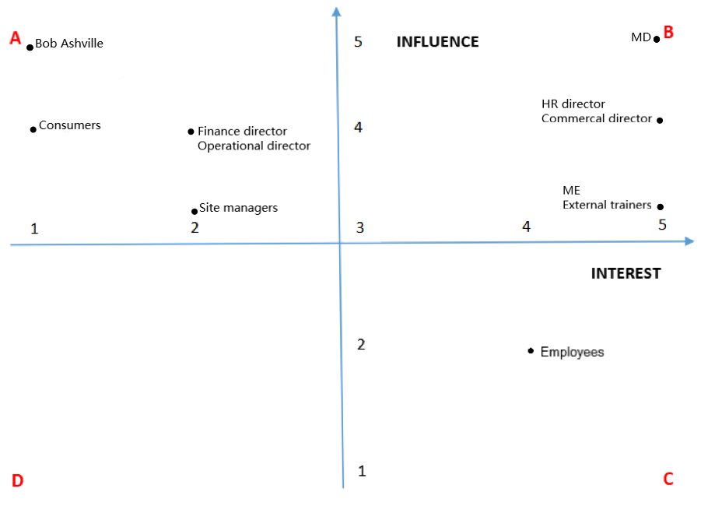

**Building Relationships:**

**Task 3: -**

**Project Overview:**

Please ensure that you have completed Task 2 the **Influence / Importance Matrix** before you move on to task 3.

You must now create a broad **project Overview,** ensure that you cover the six main points below within your project overview and highlight at minimum of 8 tasks that will be completed during the project:

* **Scope:** defines what will be covered in the project.
* **Resource:** what can be used to meet the scope.
* **Stakeholders:** relevant to the project.
* **Time:** what tasks are to be undertaken and when.
* **Quality:** the spread or deviation allowed from a desired standard.
* **Risk:** defines in advance what may happen to drive the plan off course, and what will be done to recover the situation

|  |
| --- |
| Project Overview |
| **Scope:**  The company has Decided to make an organisational change within the business  by introducing Continuous improvement and lean manufacturing.  His goal is to implement a plan over the next 3 – 5 years that develops a   continuous improvement culture across the whole of the business. |
| **Resources:**   * Company property * Machineries * Employees/ Workforce |
| **Stakeholders:**   * MD * Founder- Bob Ashville * Employee * Customer * Operational manager * Site manager * HR manager * Clients * Commercial Director * Me – Cl Consultant |
| **Time:**  **Duration: (3-5years)**   * To achieve a safe working environment. * To increase employee retention. * To increase Customer satisfaction. * To increase Job security for the workforce. * To increase employee Job satisfaction |
| **Quality:**   * Increase workforce efficiency * Reduce accumulation of waste * Improve production methods |
| **Risk:**   * Cost Risk- Project costing more than the estimated cost * Market risk– This is due to change in rate, competition etc * Legal risk   **Mitigation:**  Mitigation is a strategic risk response wherein a project team takes active steps to reduce the probability or impact of a negative risk to a project. |
| **Tasks**:  ● To be the preferred/ sole supplier of potato products to their existing  supermarket client  ● To be named as good in sector  ● To achieve a safe working environment  ● To increase customer satisfaction from 88.2% to 95%  ● To increase the job security for the workforce  ● To increase employee job satisfaction from 63% to 90%  ● To increase employee retention by 5%  ● To decrease the employee sickness level 4.1% to2% |
|  |

**Building Relationships:**

**Task 4: -**

**RACI Matrix**

Please ensure that you have completed Task 3 the **Project Overview** before you move on to task 4.

You must now complete the **RACI Matrix** for the Ashville Pork Project. In the RACI Matrix, please ensure that you include all the tasks that you have included within the Project overview and define the role and involvement of all the stakeholders you have included within the project overview, identifying their involvement using the key below.

**Ashville Pork:** **RACI Matrix**

**NB: R – Responsible; A – Accountable; C – Consulted; I - Informed**

|  |  |  |  |  |  |  |  |  |  |  |
| --- | --- | --- | --- | --- | --- | --- | --- | --- | --- | --- |
| Names=  TASKS |  | STAKEHOLDERS | | | | | | | | |
| MD | Operational manager | Commercial manager | Financial manager | HR director | Site manager | Customer | Employee | Distributer |
| 1. Management |  | R | C |  | A | I | I | R | I | C |
| 2.  work visiting& Distribution |  | C | A |  | I |  | R |  | A | R |
| 3.development and implementing strategies |  |  | R | RI |  | A |  | I | C |  |
| 4.Reporting &revenue, accounting staff |  | I | A | C | R |  | I |  | A | C |
| 5.Organizing human resource issue |  | C | R |  | A | C |  | I |  | A |
| 6.Daily report& improvement |  | A | C |  | A |  | C | R | R |  |
| 7.decision making in operation activities |  | R | R | I |  | C |  | A |  | C |
| 8.Product price & Buyer |  | I | C |  | I | C |  | R |  | I |
| 9.Report making |  | C | C |  | A |  | I |  | R |  |
| 10.announcement |  | R | C | C | A | C | I | A | I | I |

**Building Relationships:**

**Task 5: -**

# Negotiation Action Plan

Please ensure that you have completed Task 4 the **RACI Matrix** before you move on to task 5.

You must now identify the areas of the project that you may be required to negotiate to secure the support of stakeholders or the sharing of resources, you need to ensure you have identified what you want success to look like, who will be involved in the negotiation and what will ensure success. Once you have identified these you must complete the **Negotiation Action Plan** below:

**Negotiation Action Plan:**

|  |  |  |  |  |
| --- | --- | --- | --- | --- |
| Purpose of negotiation | Desired Outcome | Who will be involved? | Group-based or individual | Factors that might increase success |
| Implementing the continuous improvement & lean manufacturing | Customer satisfy should be increase from 84% to 93%  Workplace should be achieved as safe work environment | MD  Management director  Founder in Bob Ashville | Both individual to group based | MD has responsible to handle the current scenario very carefully   * Preparing for increasing products with productivity. * Listening the current scenario with needing changes due to some back failure in industry.   Responding to changes for which is needed |
| To operate more effective and efficient ways: reducing waste, saving cost etc. | The understanding should be good between board of directors with employees | MD  Bob Ashville  Board of director | Group based | More cases should be prepared with board members  Training and implementing techniques should be planned |

**Building Relationships: -**

# Task 6:

# Stakeholders Engagement Strategy

Please ensure that you have completed Task 5 the **Negotiation Action Plan** before you move on to task 6.

You must now develop a brief **Stakeholders Engagement Strategy;** this will help you to plan how often you will need to communicate with the different groups and decide which tools to use for each one. The strategy must provide details of:

1. A prioritised communication plan that you will follow
2. Identification of potential conflicts and a detail plan of how they will address them.

**Stakeholder Engagement Strategy:**

|  |
| --- |
| **Communications plan:**  Communication is a main way to connect with people and discuss about the project plan in all ways. With a good communication plan the project will be more effective and complete before the deadline. Some of the plans are   * Meetings (staff, board, weekly). * A weekly report which provides the details of the status of the project * Quality audit report – The meeting provides the details of quality and performance can held at weekend. * Making it popular such as reaching information to all stakeholders with connection through selection channel, media, mail, advertisements etc. * Board meeting - Project related information discussed among the board of directors. |
| **CONFLICTS AND RESOLUTIONS:**  **Conflict**: An independent conflict between the managers of north site and south site.  **Resolution:**   * Disagreement: The main disagreement is because of mode of training and initiatives. * Common goals: All the sites are treated equally for the training and initiative steps. * Ways to reach goals: The deliverable and resources should be managed in all sites equally * Barriers: The planning should be favour to the employee’s health and production of the company and the time planned to complete the project.   **Ways to resolve the conflict:**   * Proper discussion with the site manager. * Based on the availability of trainees and their time scheduling the training should be conducted. * The project should be planned in terms of not affecting the productivity. |

